Setting up Application Environment

Create SendGrid Account

Step 1. Navigate to [https://sendgrid.com](https://sendgrid.com/)

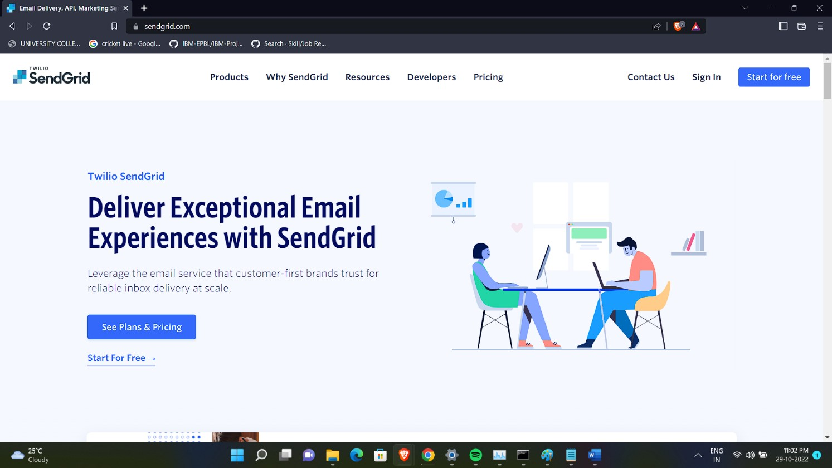

Step 2. Click on “Start for free” and register yourselves by entering required details and click on create account

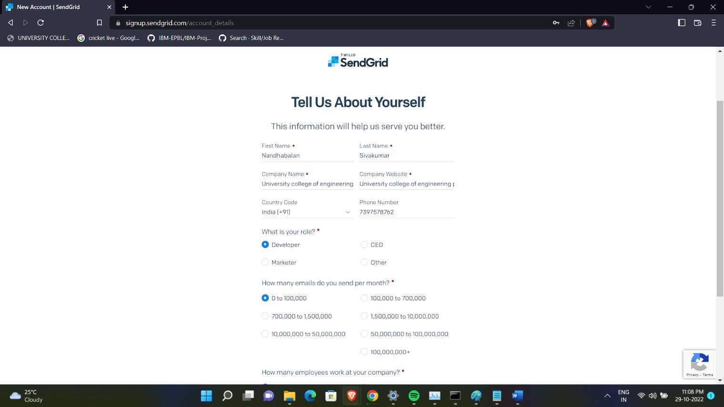

Step 3. Further fill all required details in next page and click on get started as shown below

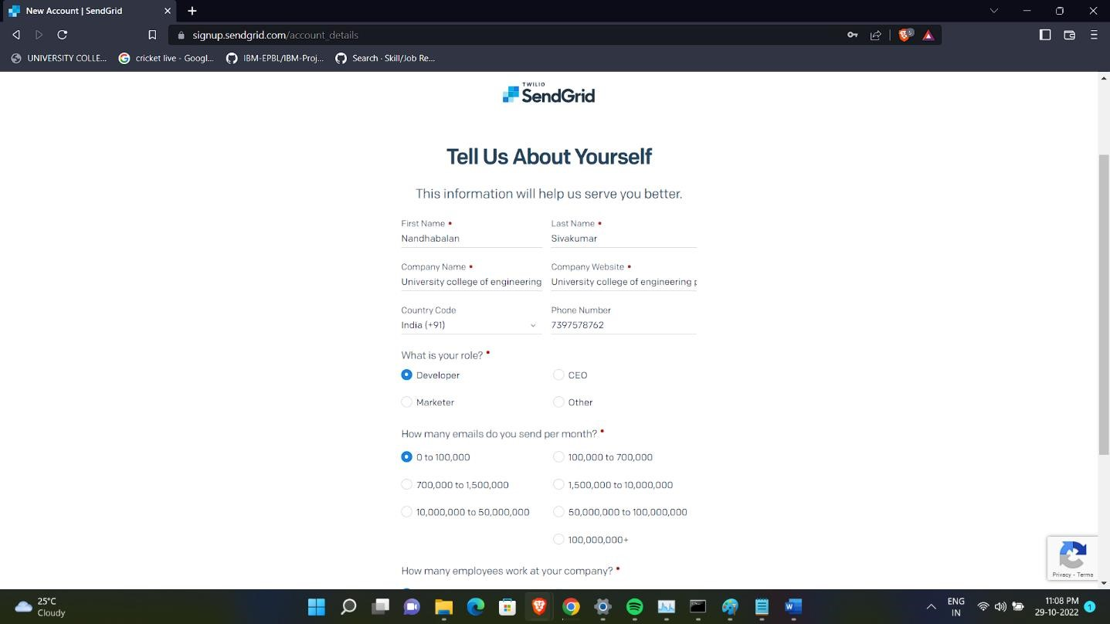

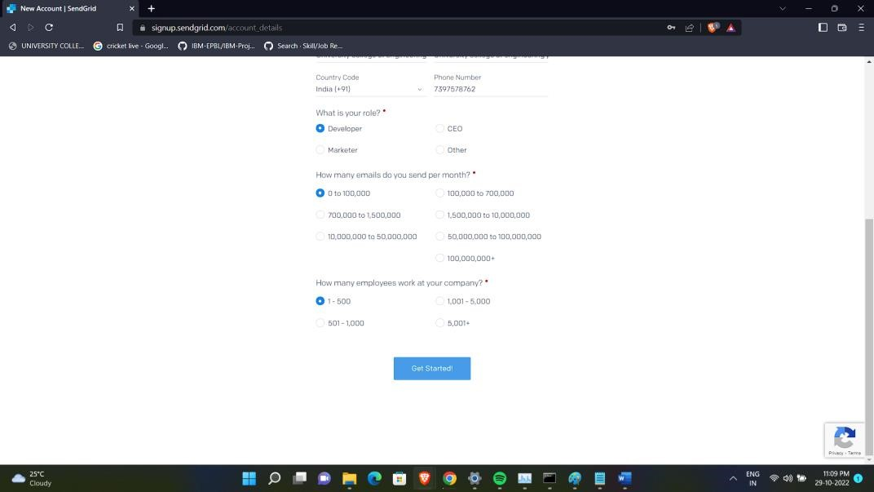

Step 4. That’s it you have created your SendGrid account and got access to dashboard

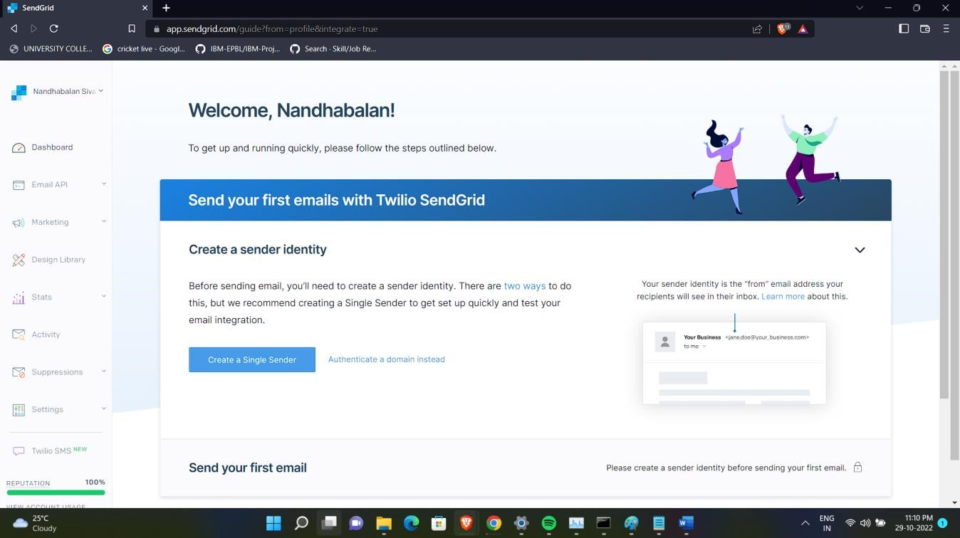

Output:

Send Grid account created successfully.